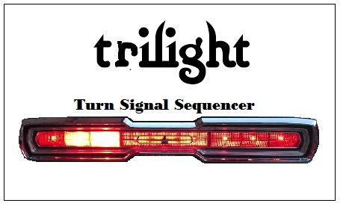
Thank you for purchasing the trilight turn signal sequencer for your 1964 Thunderbird. This sequencer is designed to integrate with your existing wiring requiring only some reconnection of wires at your steering column and the connections at the rear turn signal / brake light bulb sockets.
The following pages will guide you through the installation process.
Page 2 at the top is a copy of the factory wiring diagram with the trilight sequencer wiring added. At the bottom is a diagram of where to run the wiring harnesses. The wiring harness supplied has each section marked to match the diagram. Also the factory wiring harnesses routing is provided for your reference
Page 3 there is at the top a schematic diagram showing the factory connections at the base of the steering column for the turn signal switch wiring. At the bottom is a schematic diagram showing the reconnections needed. Also note to the right our schematics of some short jumpers that will be required. These jumpers are included with your wiring harness and attached to the wiring harness bundle 2 with zip ties .
Page 4 is a schematic diagram of the wiring in the trunk for the sequencer box and the new rear turn signal / brake light bulb wiring. A black ground jumper is attached to the wiring harness.
Hopefully this will provide you with the information required to successfully install the wiring harnesses and sequencer box. The harnesses are made with the sequencer mounted and roughly the same location in the trunk as the 1965 and 1966 sequencers are located. Those sequencers are mounted on a rubber piece that is suspended from the top of the site structure. But any location near the passenger side of the trunk under the rear window area will be fine.
PAGE 1
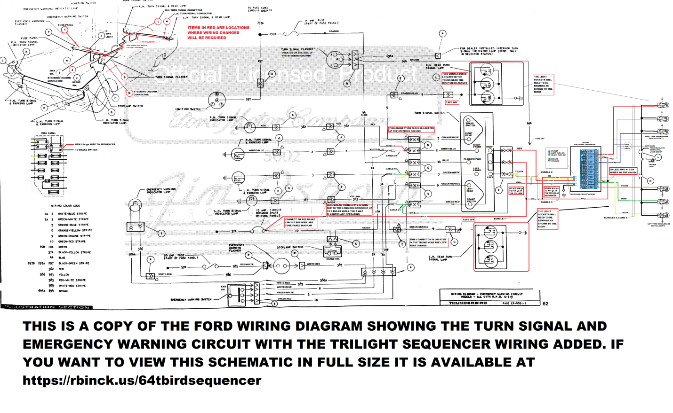

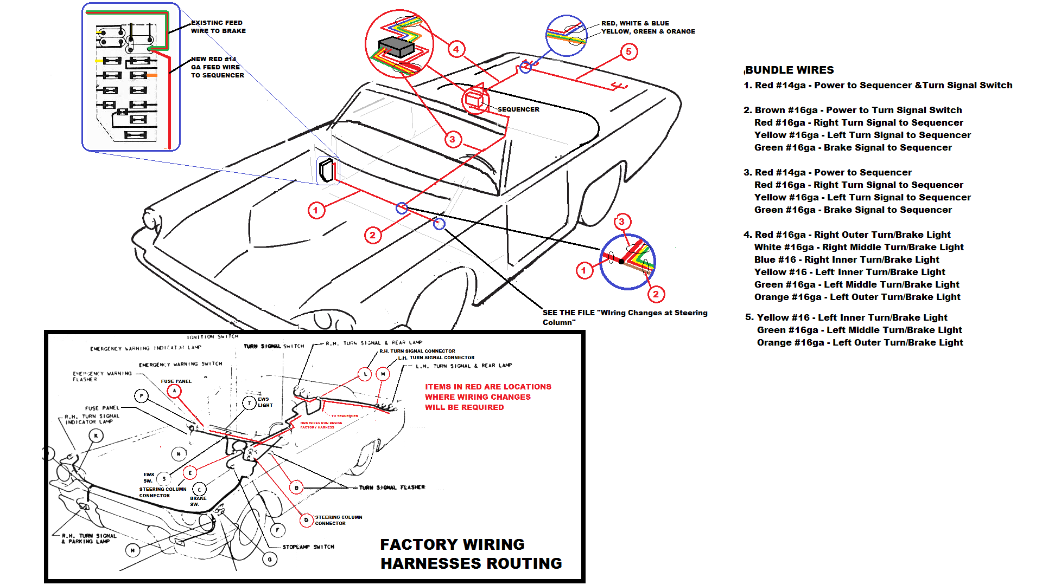 PAGE 2

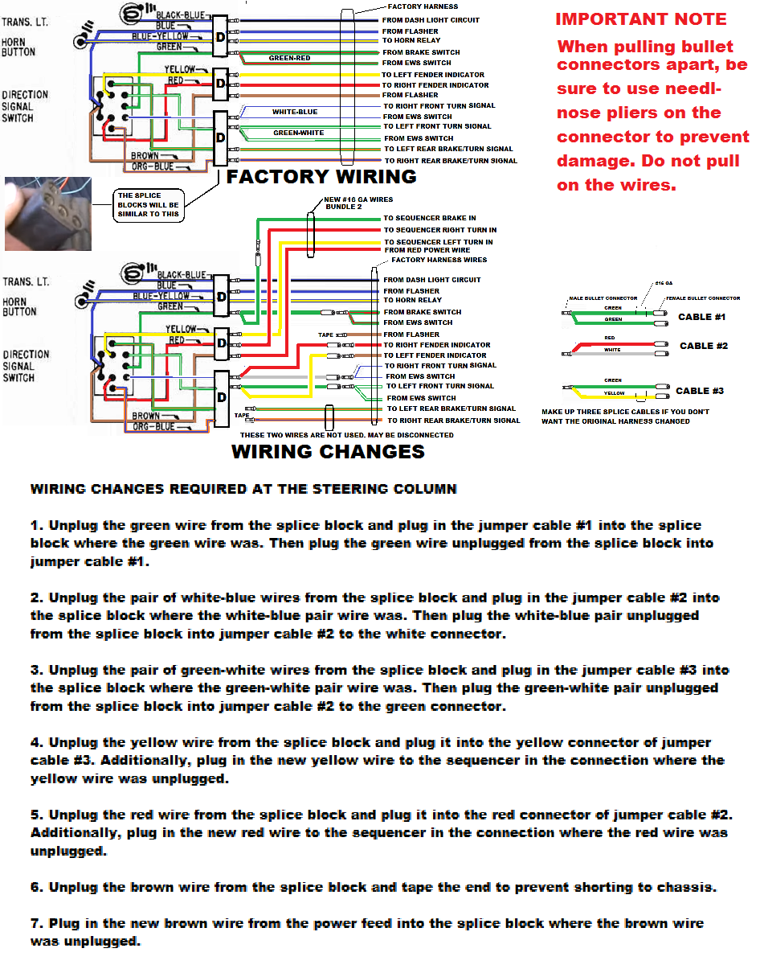 PAGE 3
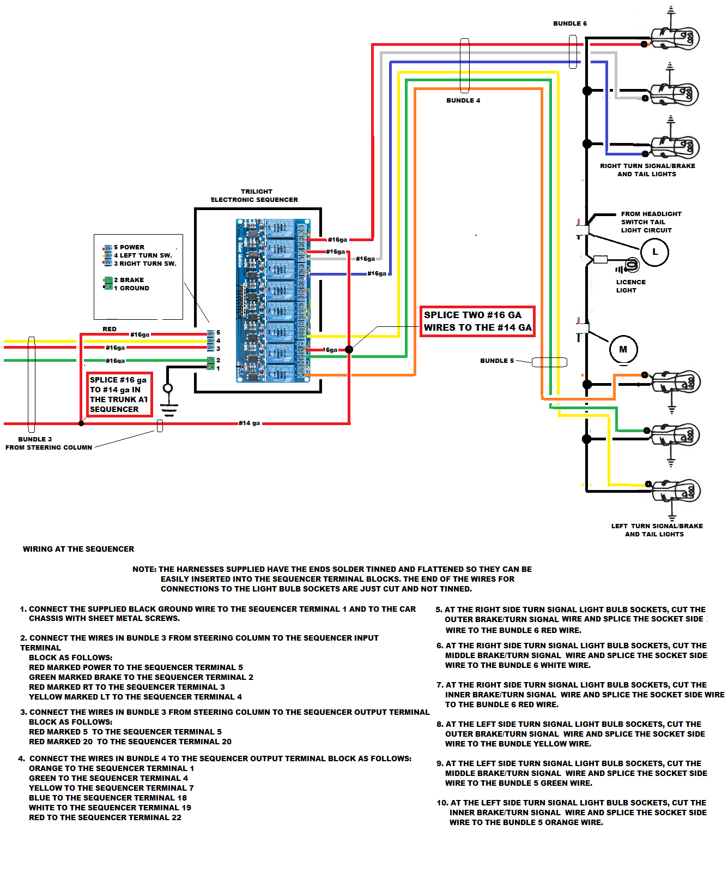PAGE 4

